**Human Resources Migration Workflow System**

Human Resources Machine

**Section 3. Application Design for Workflow Information System**

**Section 3.2 User Interface Design**

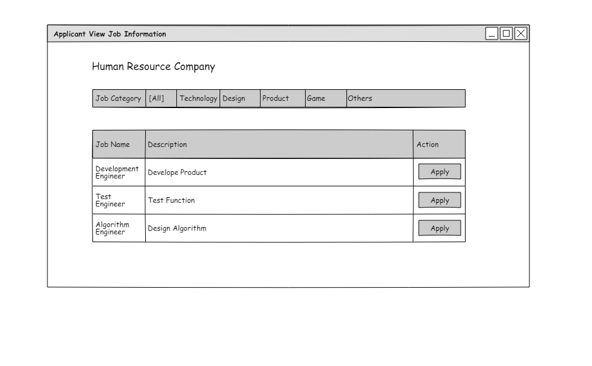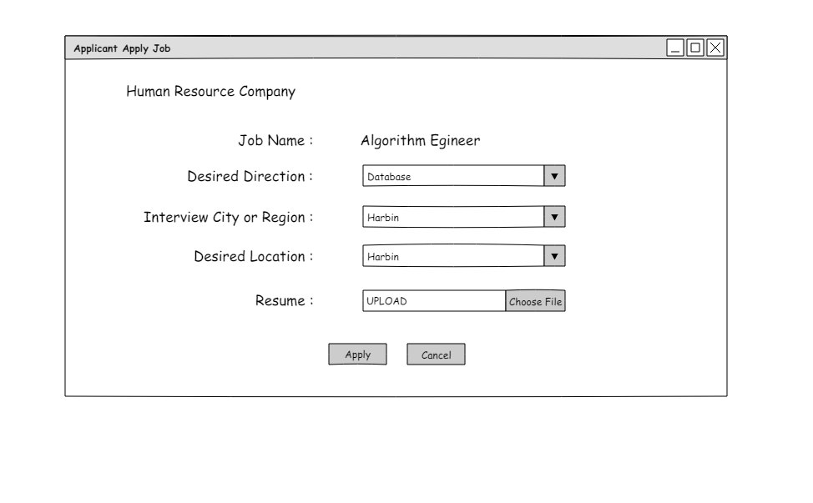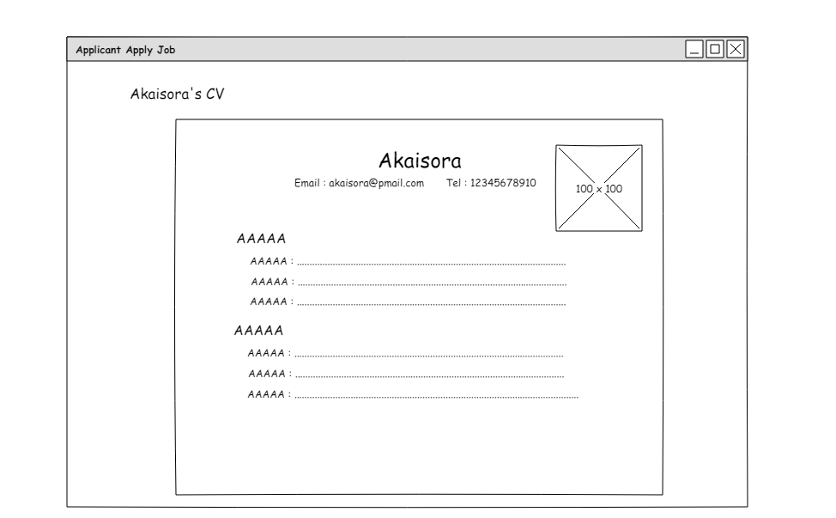

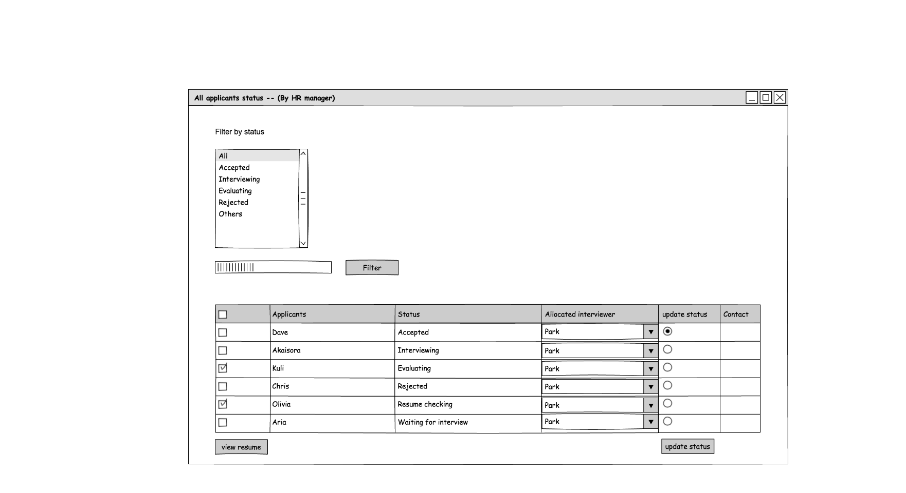

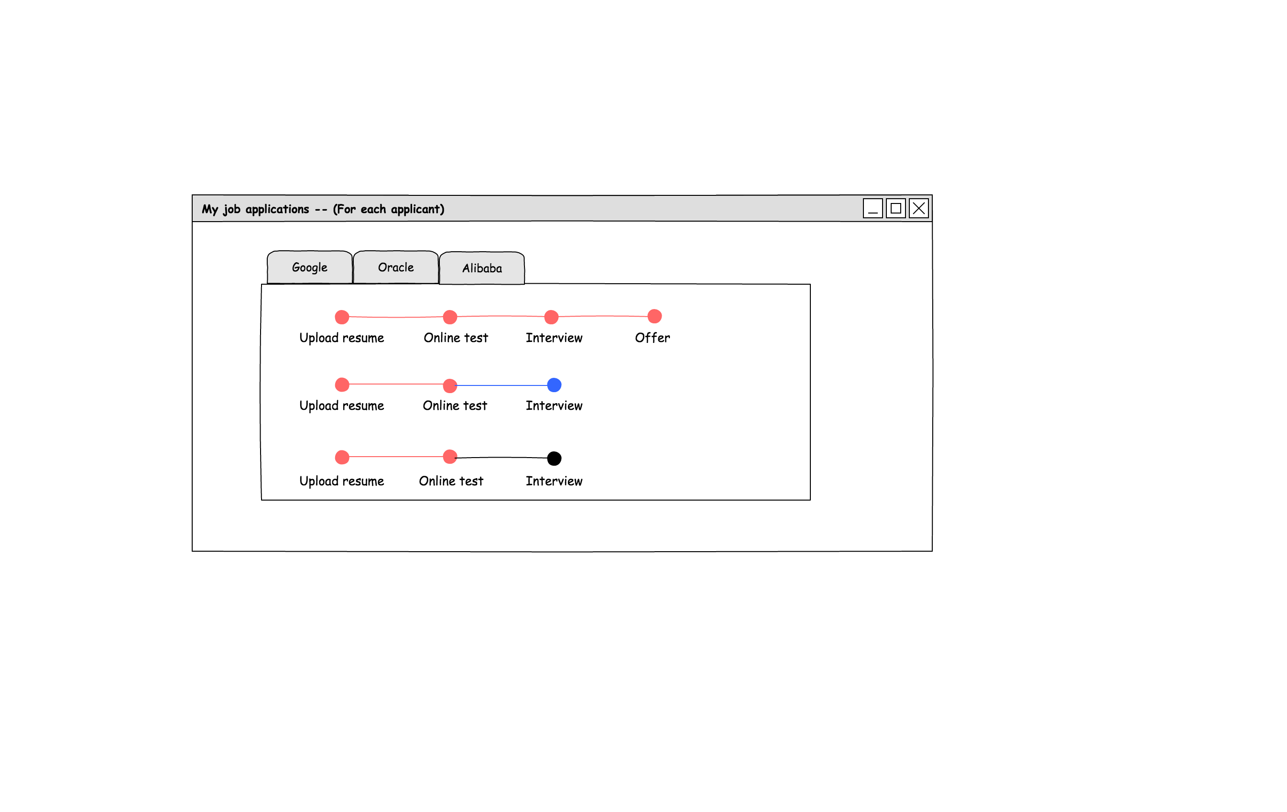

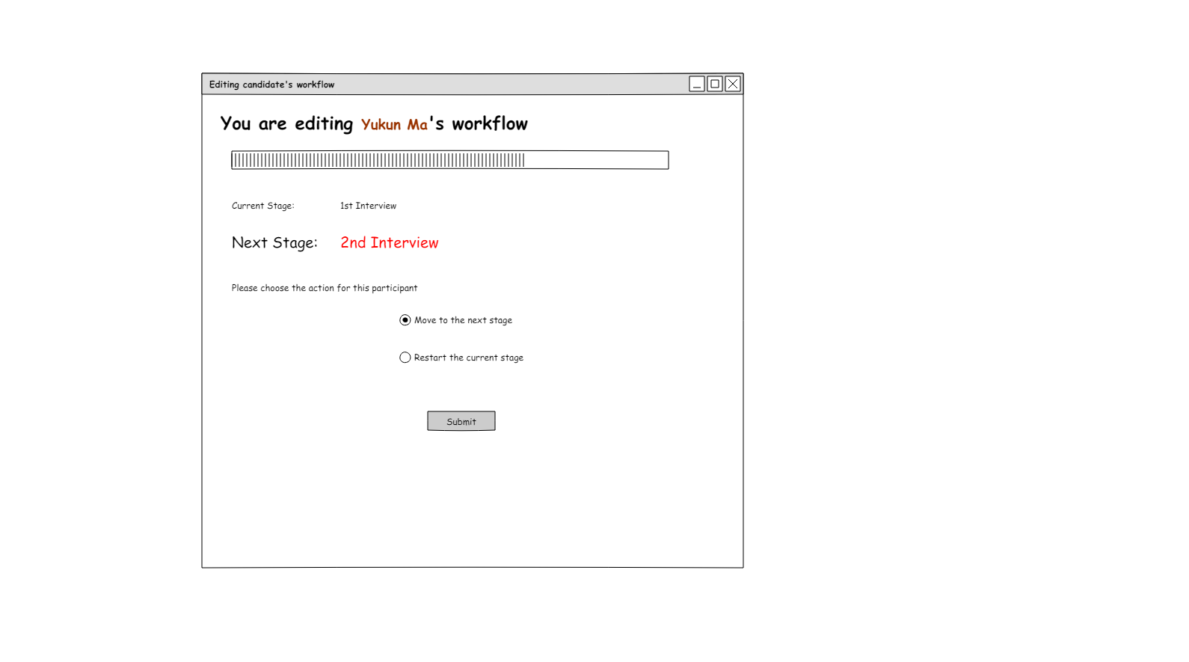

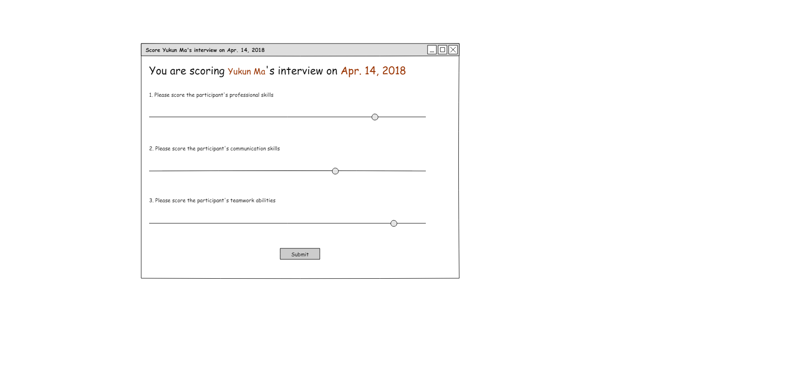

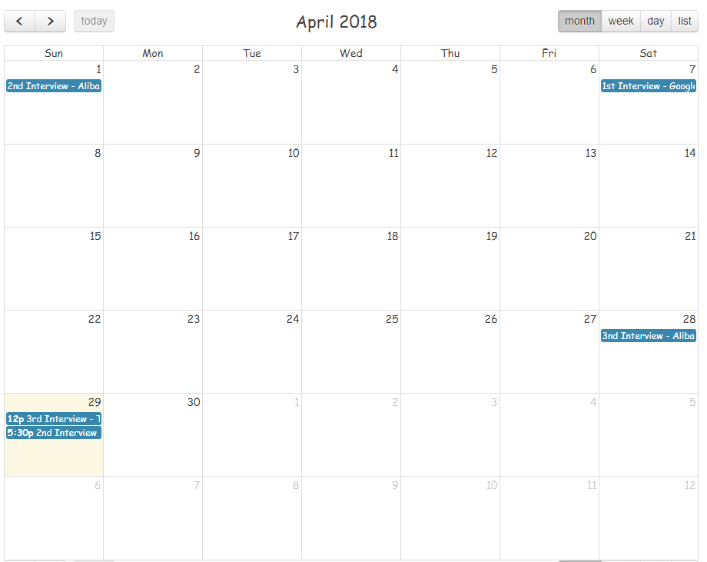

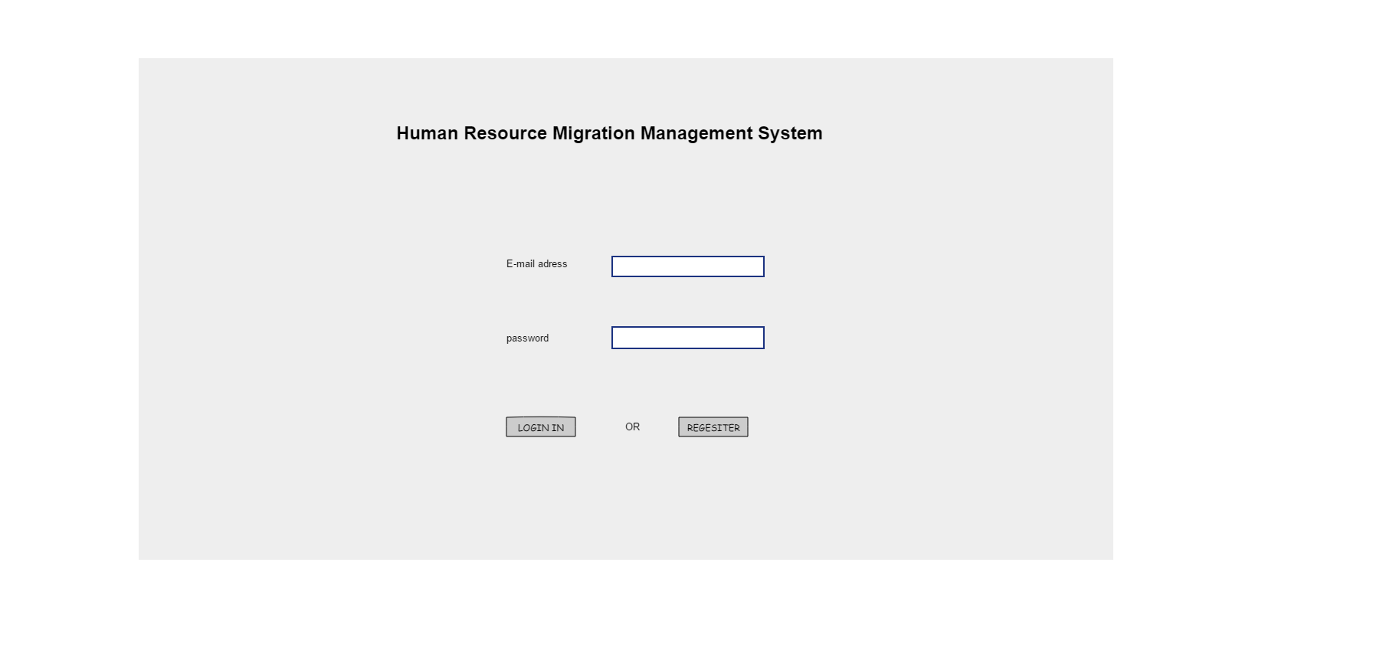

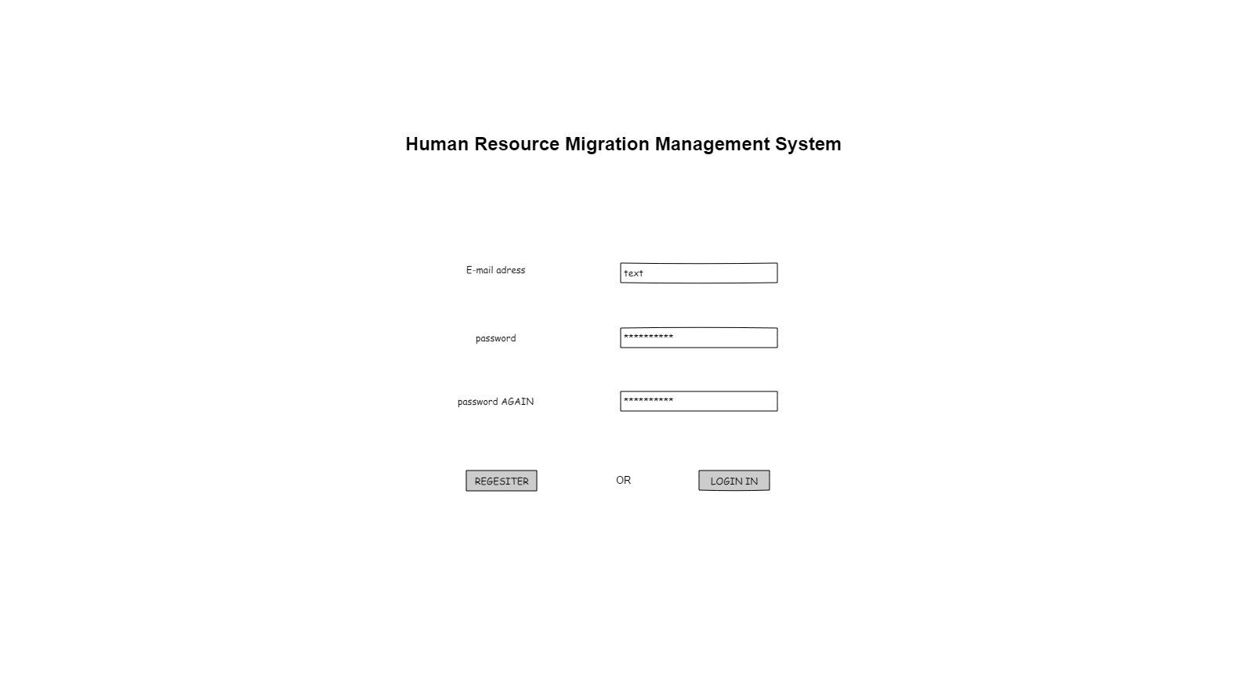

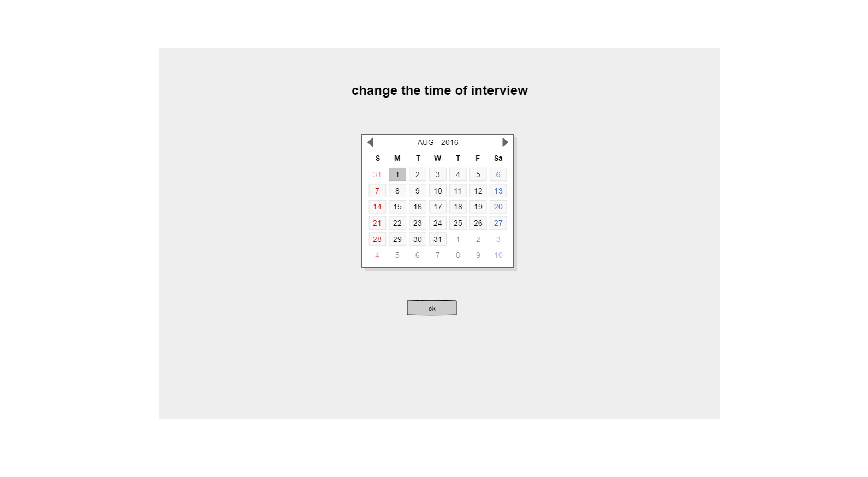

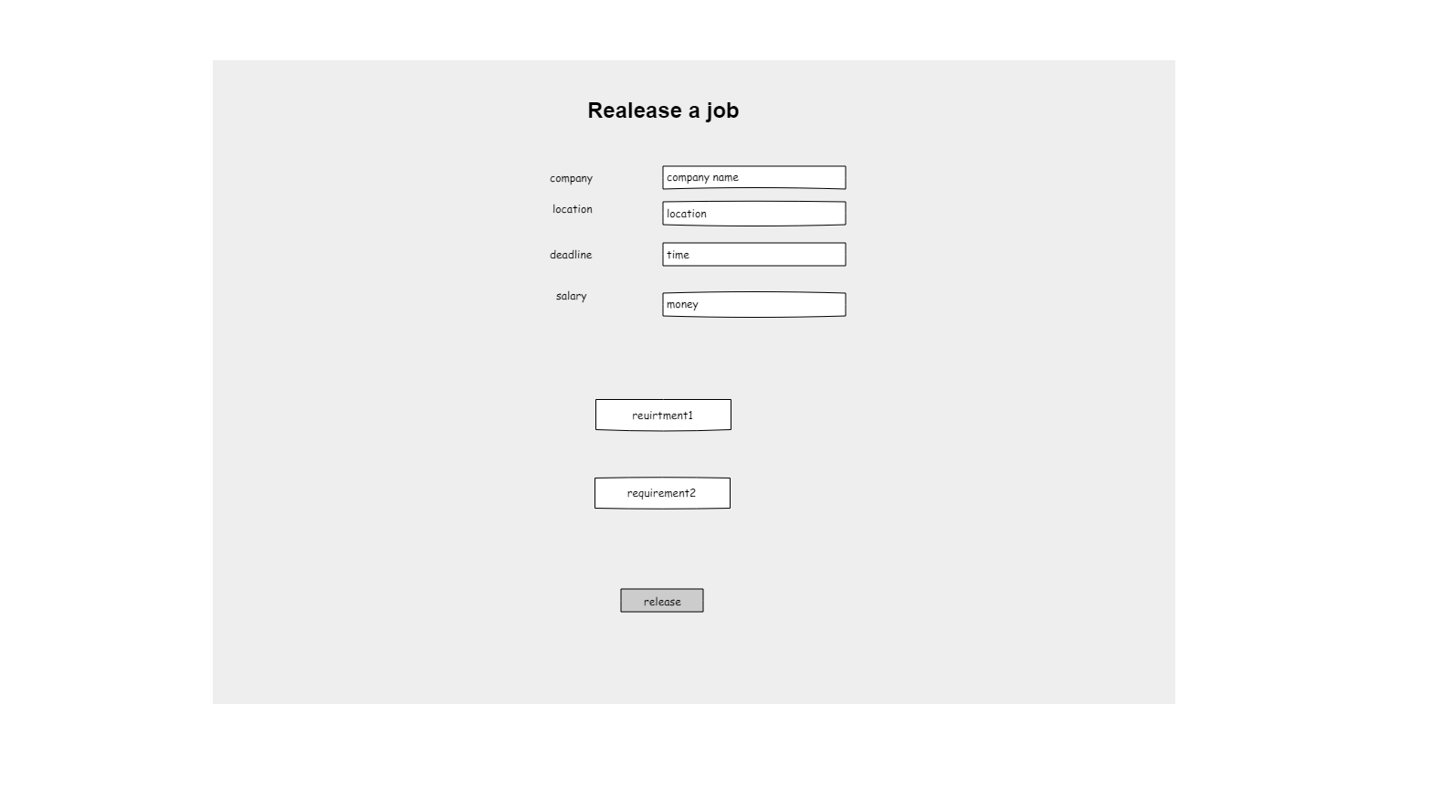

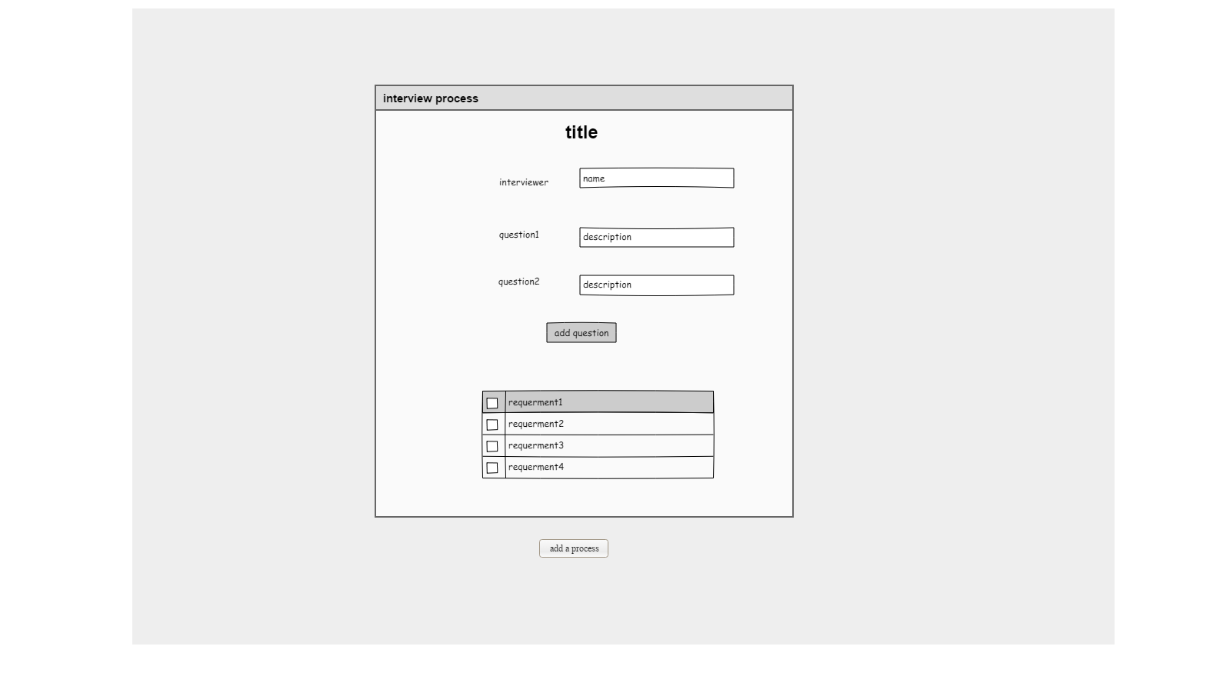

**Section 3.2 Your Meeting Log**

|  |  |  |  |  |  |
| --- | --- | --- | --- | --- | --- |
| ***No*** | ***Date and time*** | ***Duration*** | ***Location*** | ***Discussion topic*** | ***Attenders*** |
| 1 | 3/17/2018:3:00pm | 2.5 hrs | 709 Gewu | Project selection | Ning Zhang  Yingkai Sun  Yue Han  Yukun Ma |
| 2 | 3/23/2018:3:00pm | 2 hrs | 709 Gewu | Requirements | Ning Zhang  Yingkai Sun  Yue Han  Yukun Ma |
| 3 | 3/25/2018:8:00pm | 2 hrs | 709 Gewu | Requirements | Ning Zhang  Yingkai Sun  Yue Han  Yukun Ma |
| 4 | 4/1/2018:4:00pm | 2 hrs | 709 Gewu | Requirements | Ning Zhang  Yingkai Sun  Yue Han  Yukun Ma |
| 5 | 4/8/2018:19:00pm | 2 hrs | 709 Gewu | Use Case Diagram | Ning Zhang  Yingkai Sun  Yue Han  Yukun Ma |
| 6 | 4/14/2018:21:00pm | 1 hr | 709 Gewu | Use Case Diagram | Ning Zhang  Yingkai Sun  Yue Han  Yukun Ma |
| 6 | 4/22/2018:16:00pm | 3 hrs | 709 Gewu | Application Design | Ning Zhang  Yingkai Sun  Yue Han  Yukun Ma |
| 6 | 4/29/2018:20:00pm | 3 hrs | 709 Gewu | User Interface Design | Ning Zhang  Yingkai Sun  Yue Han  Yukun Ma |